Exercise :1 Singleton Pattern Example
public class Logger {
private static Logger log;
private Logger(){
System.out.println("Logger");
}
public static Logger getLogger(){
if(log == null){
log = new Logger();
}
return log;
}
public void log(String message){
System.out.println(message);
}
}
public class Main {
public static void main(String[] args) {
Logger log1 = Logger.getLogger();
Logger log2 = Logger.getLogger();
log1.log("First Log message");
log2.log("Second Log message");
if(log1 == log2) {
System.out.println("both instances are the same");
}
else{
System.out.println("both instances are not the same");
}
}
}
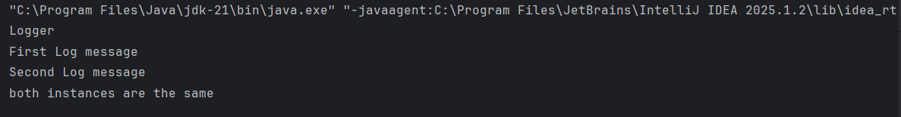

2.FactoryMethodPattern Example
public interface Document {
void open();
}
public abstract class DocumentFactory {
public abstract Document createDocument();
}
public class ExcelDocument implements Document {
@Override
public void open() {
System.out.println("open excel document");
}
}
public class ExcelFactory extends DocumentFactory{
@Override
public Document createDocument() {
return new ExcelDocument();
}
}
public class Main {
public static void main(String[] args) {
DocumentFactory wordFactory = new WordFactory();
Document word = wordFactory.createDocument();
word.open();
DocumentFactory pdfFactory = new PdfFactory();
Document pdf = pdfFactory.createDocument();
pdf.open();
DocumentFactory excelFactory = new ExcelFactory();
Document excel = excelFactory.createDocument();
excel.open();
}
}
public class PdfDocument implements Document {
@Override
public void open() {
System.out.println("open pdf document");
}
}
public class PdfFactory extends DocumentFactory{
@Override
public Document createDocument() {
return new PdfDocument();
}
}
public class WordDocument implements Document{
@Override
public void open() {
System.out.println("open word document");
}
}


